**EASTBURY SURGERY**

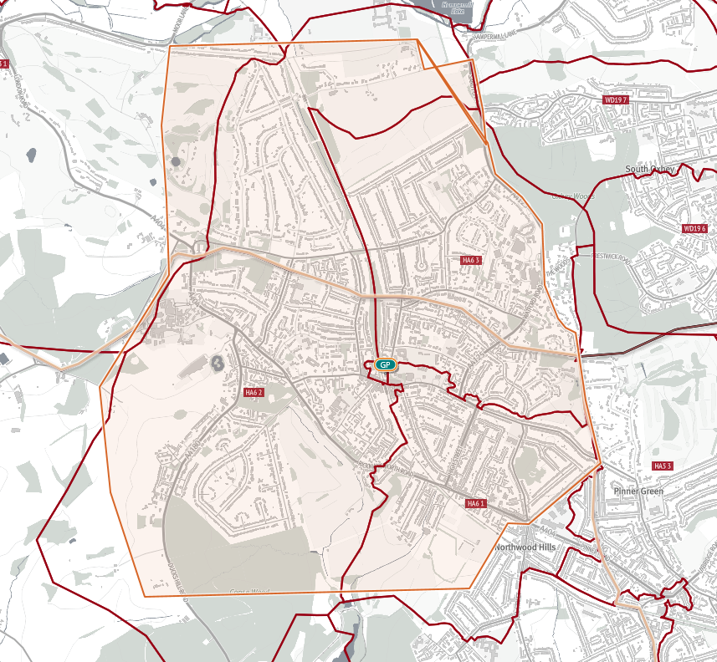**BOUNDARY MAP**